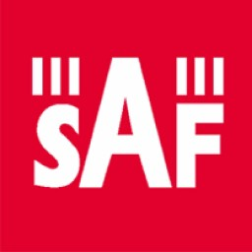

For the attention of shareholders of
Joint Stock Company „SAF Tehnika”

Board of Directors of Joint Stock Company „SAF Tehnika” (Reg.No.40003474109, registered address at: 24a, Ganibu dambis, Riga, LV-1005. Latvia) informs about the supplement to the Draft Resolutions of the annual shareholders’ meeting which will take place on 19th November 2008 at 11:00 a.m. at JSC “SAF Tehnika” administration conference room (24a, Ganibu dambis, Riga, Latvia).

Supplemented agenda (Item No.8):
1. Approval of report of the Board of Directors and the Supervisory Council;
2. Approval of the annual report and release of the Board of Directors from responsibility for financial year 2007/2008;
3. Amendments to the Articles of Association;
4. Election of the members of Revision Committee and determination of the amount of remuneration;
5. Covering of losses by undivided profit from previous periods;
6. Retaining the part of undivided profit from previous periods as retained earnings;
7. Appointment of the auditor and determination of the amount of remuneration;
8. Actions regarding the information containing an official secret.
Supplemented draft resolutions of the shareholders meeting can be found in the attachment.

